Golden Harvest Nursery- Studies
March 25, 2016 to May 17th 2016
Trials inoculating with Seed MAXX &
Soil applied Microbe MAXX
Results
Seed Coated: Treated 3/25/16
Inoculated seed plant on left.
Significantly greater root mass and biomass
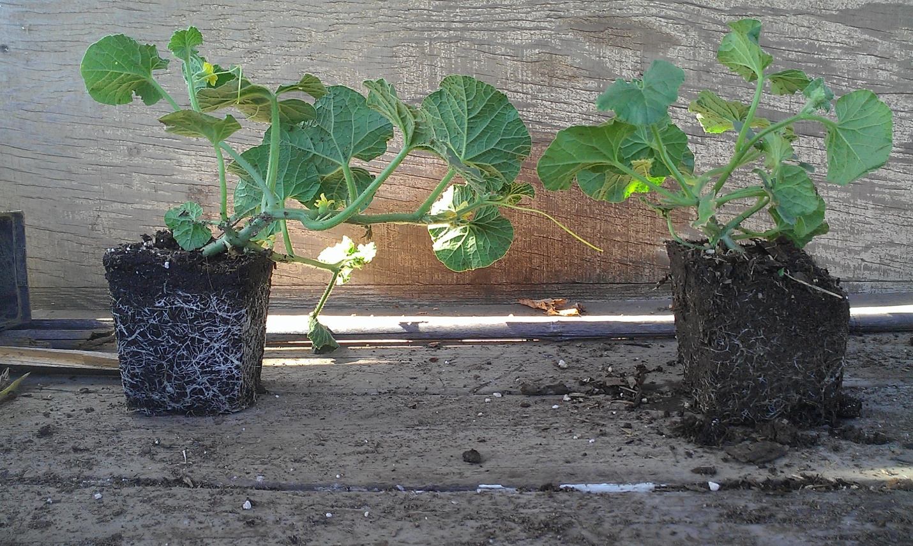
- Cantaloupe
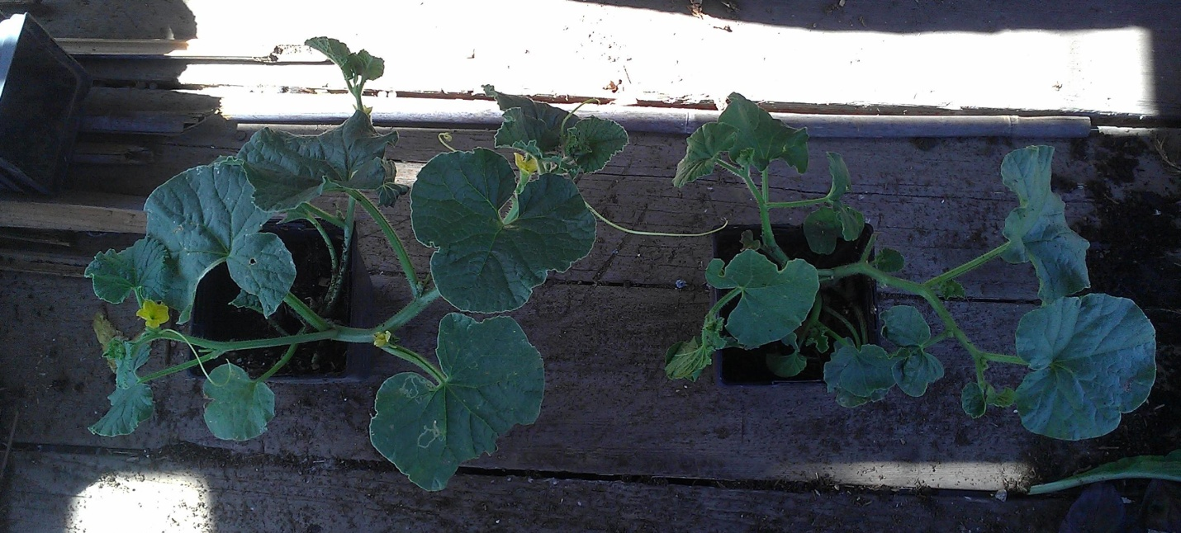
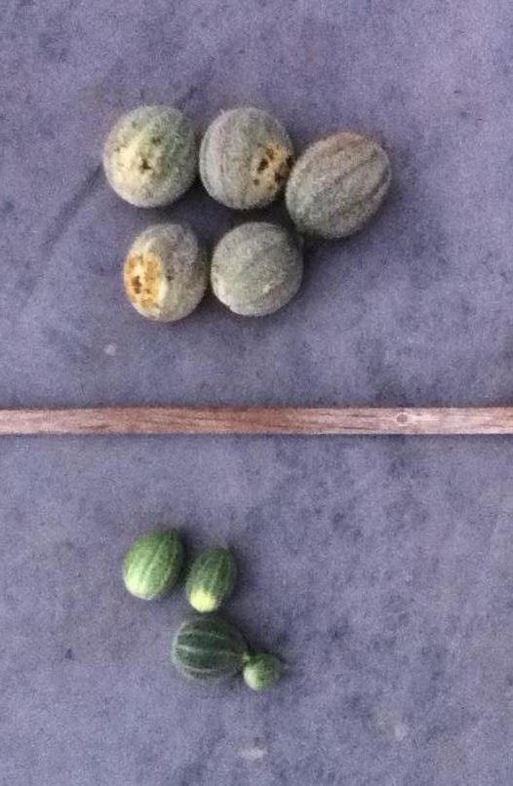
Treated vs Untreated (side and top view) Plants were transplanted to soil at 6 weeks old, and the treated plants went on to grow with more vigor and more drought resistance. Untreated plant was susceptible to pests like ants, treated plant had more significant pest resistance due to better health.
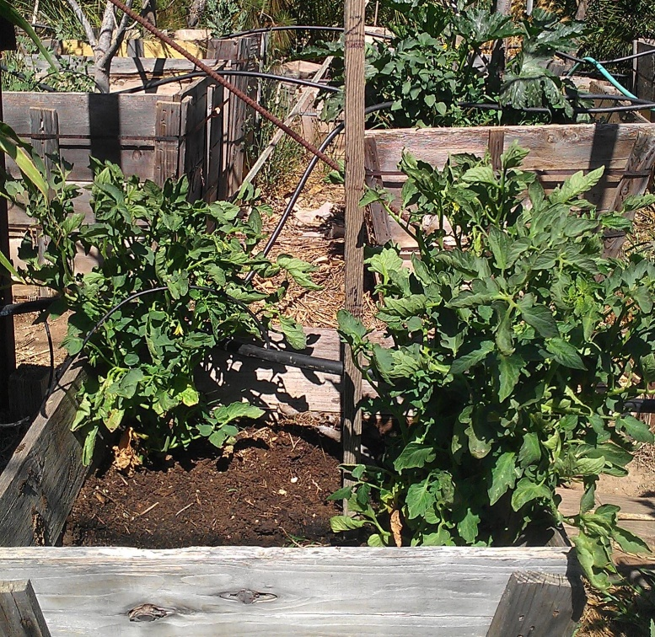
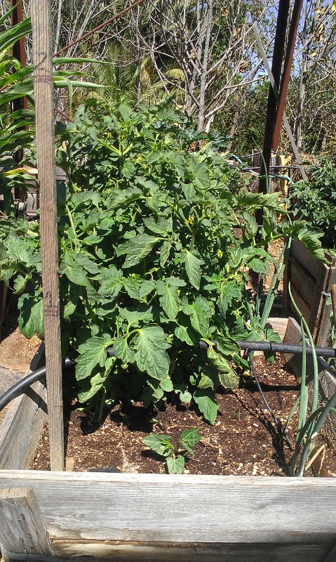
- Roma Tomato

Treated plant on left and untreated plants on right.

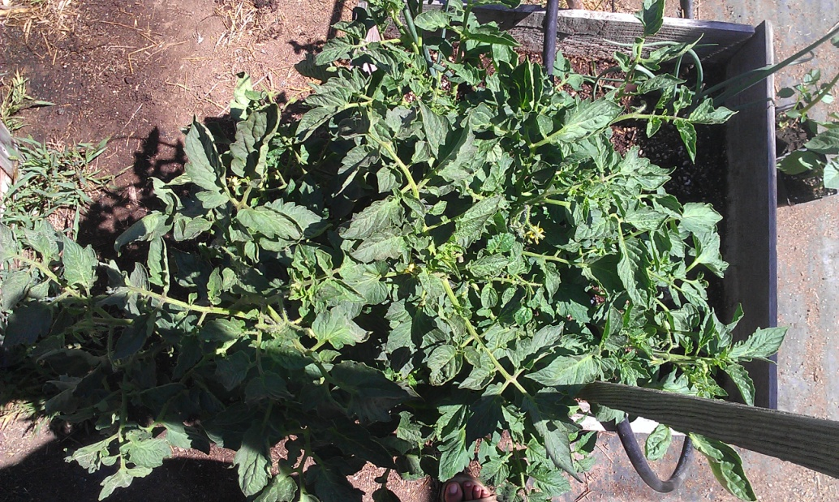

Treated plant

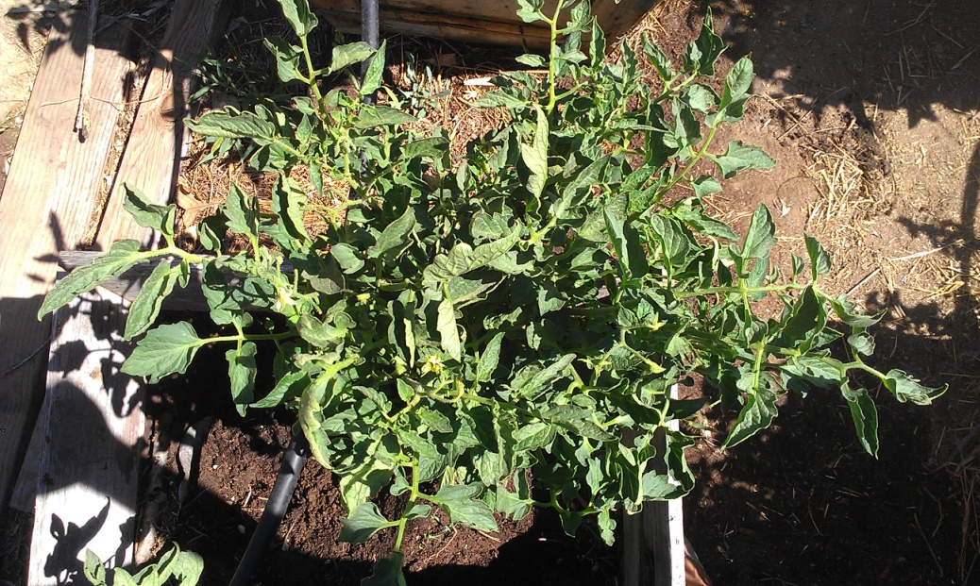
Untreated plant

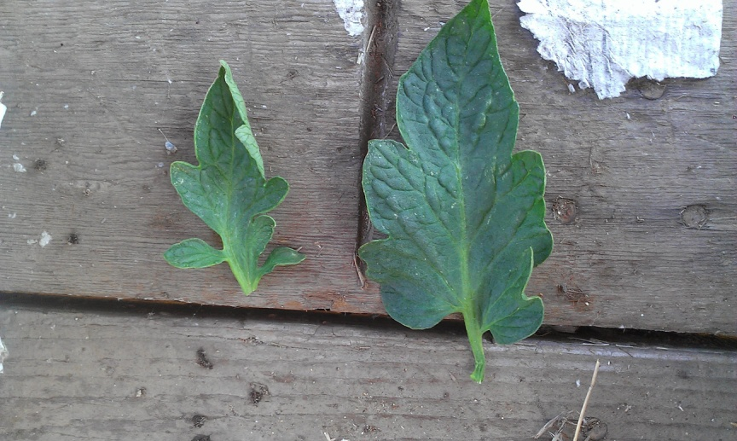
Leaf Comparison (Untreated vs Treated)

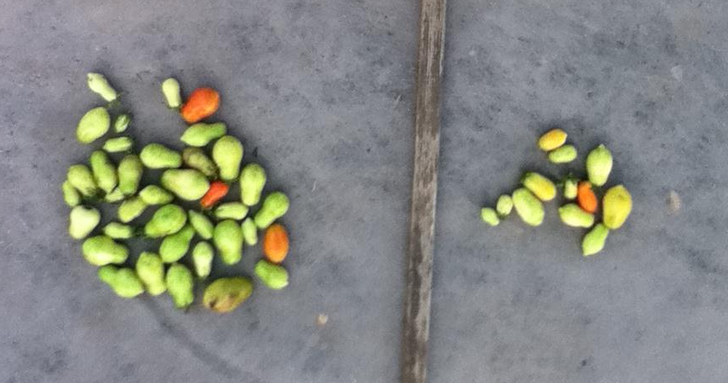

Yield (Untreated vs Treated)
Both Treated and Untreated planted as seed, treated plants were coated with Seed MAXX.
Microbe MAXX was then added to the soil prior to planting the seeds.
Treated plant grew bigger, stronger, and more drought resistant. Treated tomato plant was 5 days younger than the untreated.
- Corn (Golden Bantam Sweet Corn and Sweet Corn Early Sunglow)
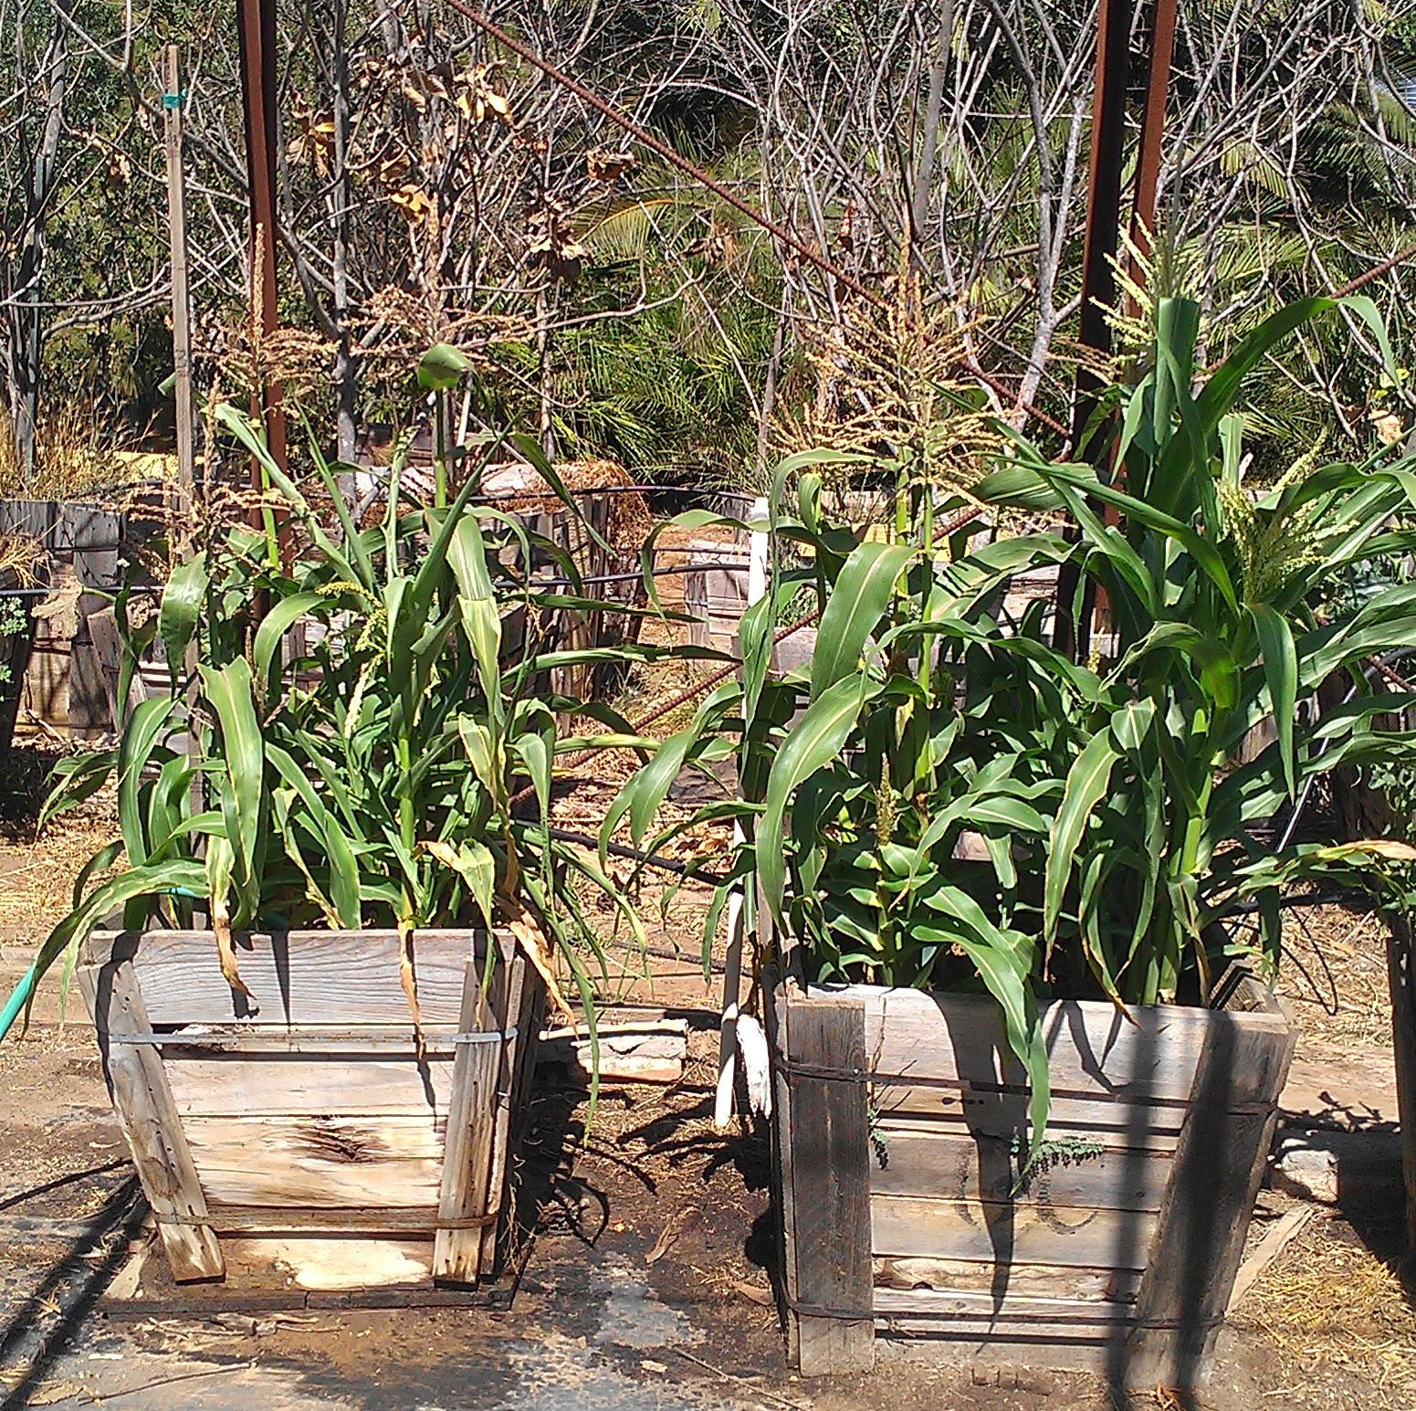
Untreated corn on the left, and treated corn on the right. 4 plants in each 24” box. Front right on each box is Sweet Corn Early Sunglow (white corn), all the others are yellow. Plants were transplanted at about 3 weeks old. Treated corn plants grew bigger with more tillers of a consistent size and were very drought resistant compared to the non treated plant due to the endomycorrhizae and beneficial bacteria. Some tillers or suckers even produced their own ears. Also worth noting, the treated corn was 5 days younger than the untreated corn on the left.

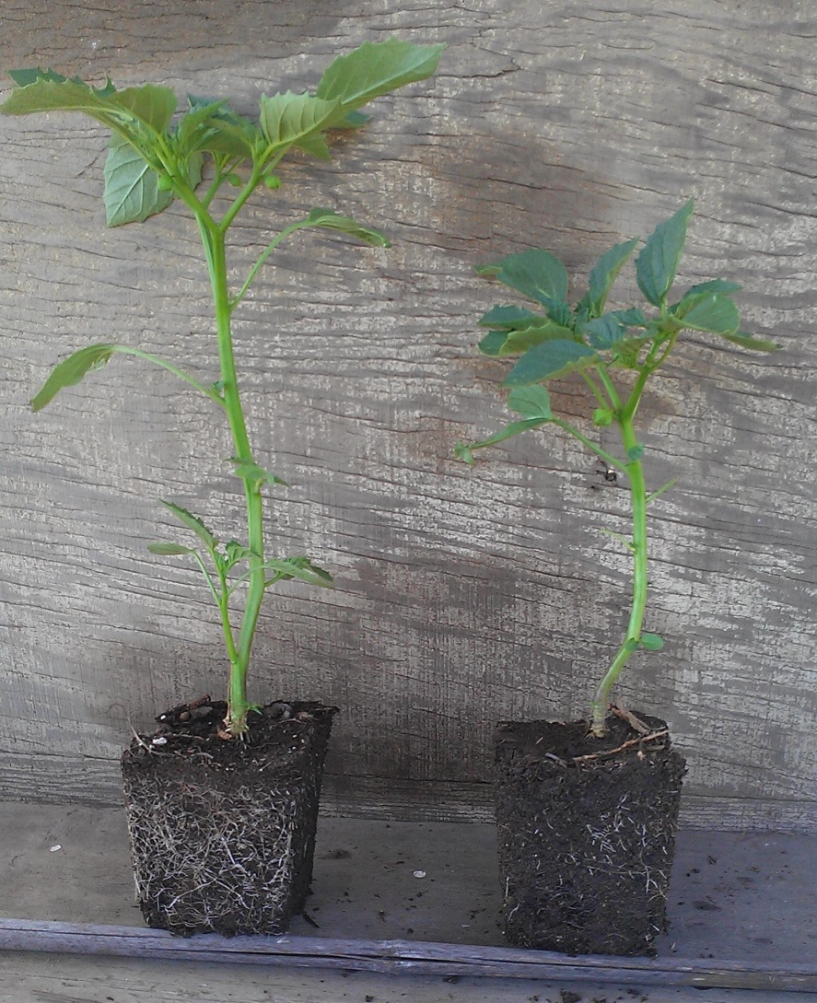
- Tomatillo
Treated tomatillo plant grew taller and wider, flowered earlier, had more root growth, and looks like it will yield more than the untreated plant. Also appears to be better drought resistant.

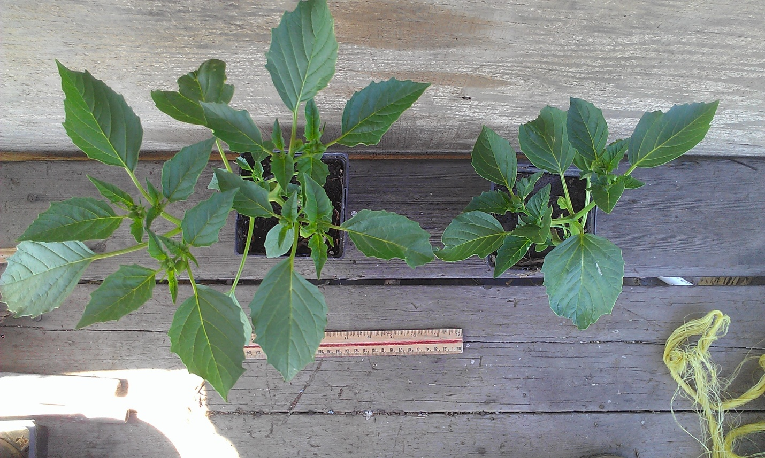
Treated vs Untreated (side and top views)

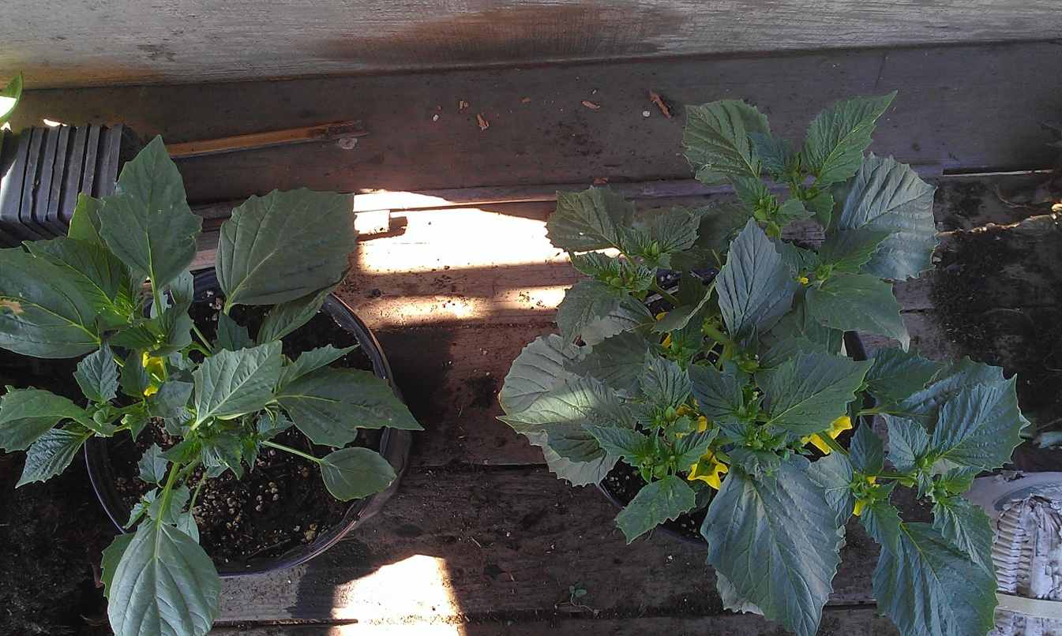

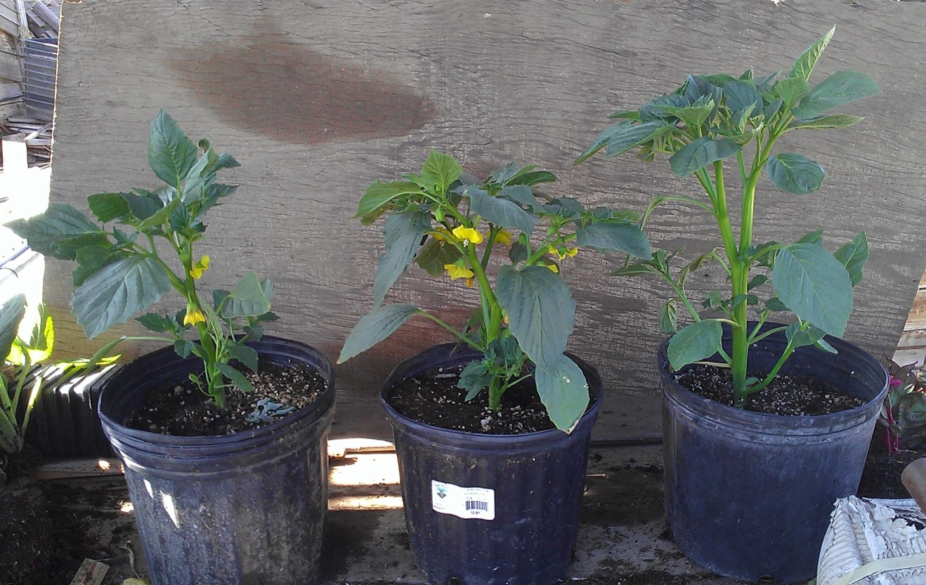
Untreated vs treated (and treated plant with Agragel in lower picture)

Treated plant shows more vigor and flowering. Treated plant with Agragel is a lot more drought resistant, can almost go off of 1 watering every 6 days.

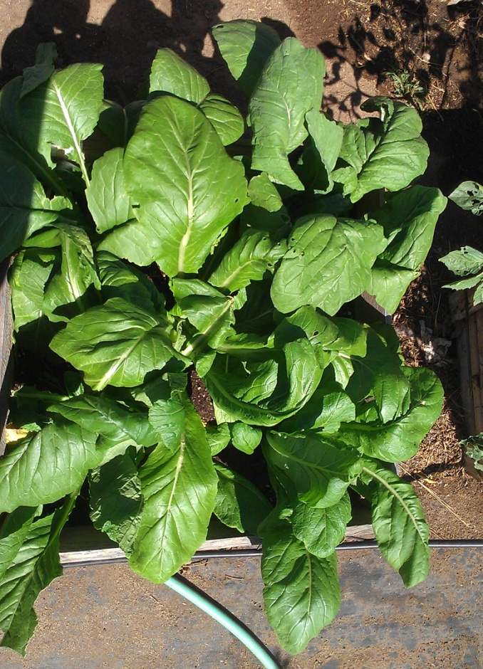
- Mustard Green
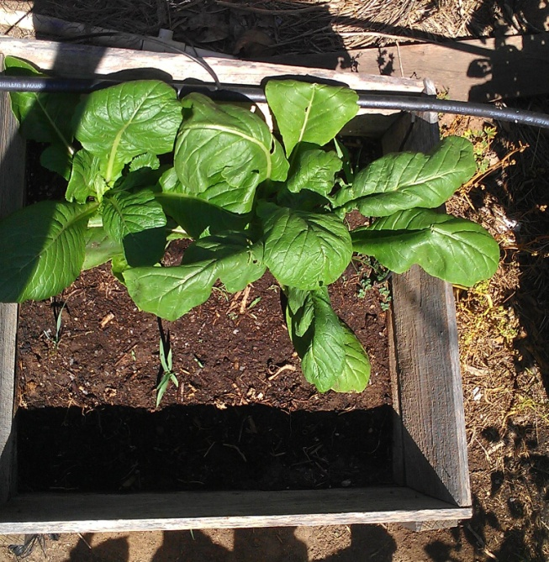

Untreated plants on left and treated on right
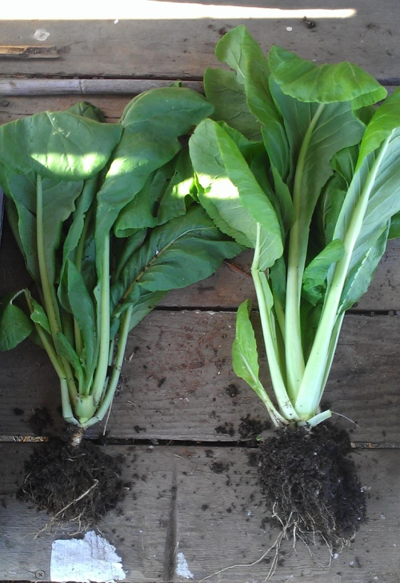
Plants were transplanted at about 4 weeks. Strong winds killed some untreated plants. Treated plants are bigger, more drought tolerant and have a bigger root zone.

Soil Drench: Treated on 4/27/14
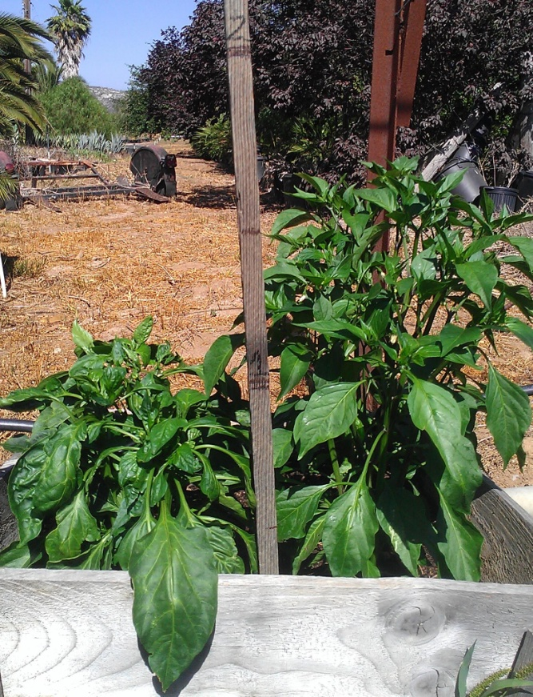
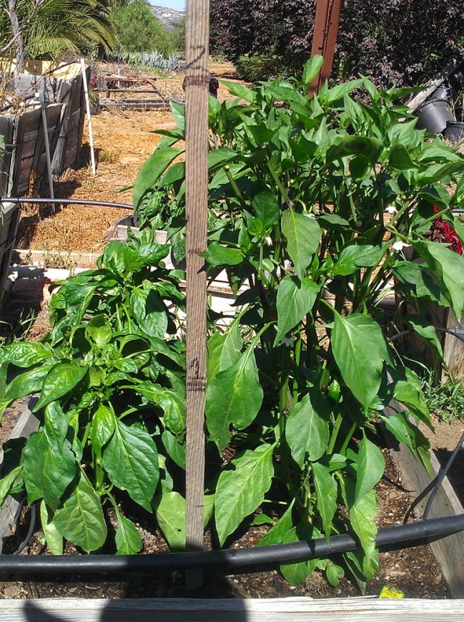
- Bell Peppers and Jalapenos

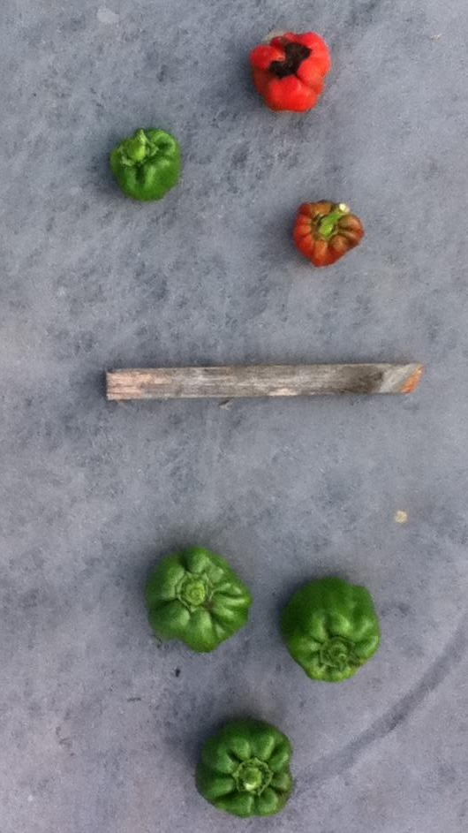
Untreated on left and Treated on right. 2 Bell peppers (shorter plants) and 2 jalapeno plants (taller) in each 24” box. Treated are about 4-5” taller and had more flowering, therefore more yield.
Bell Pepper yield
(Untreated vs Treated)

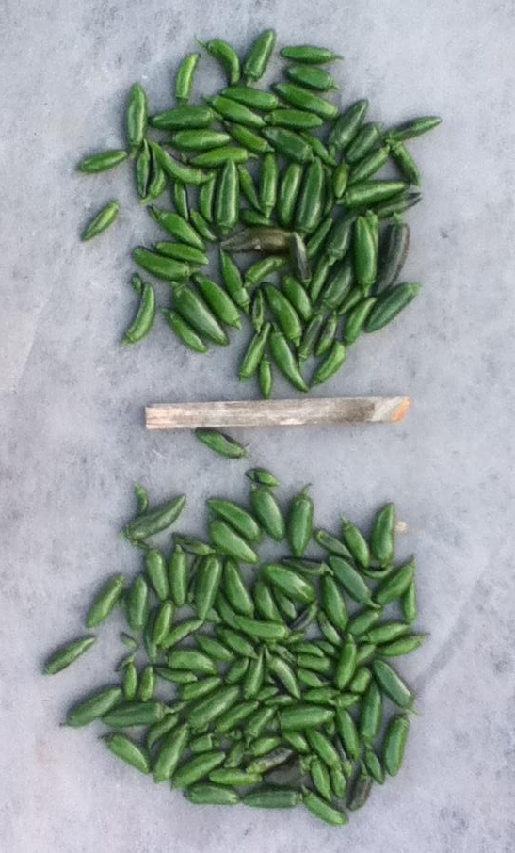
Jalapeno yield (Untreated vs treated)

- Big Bertha Bell Peppers
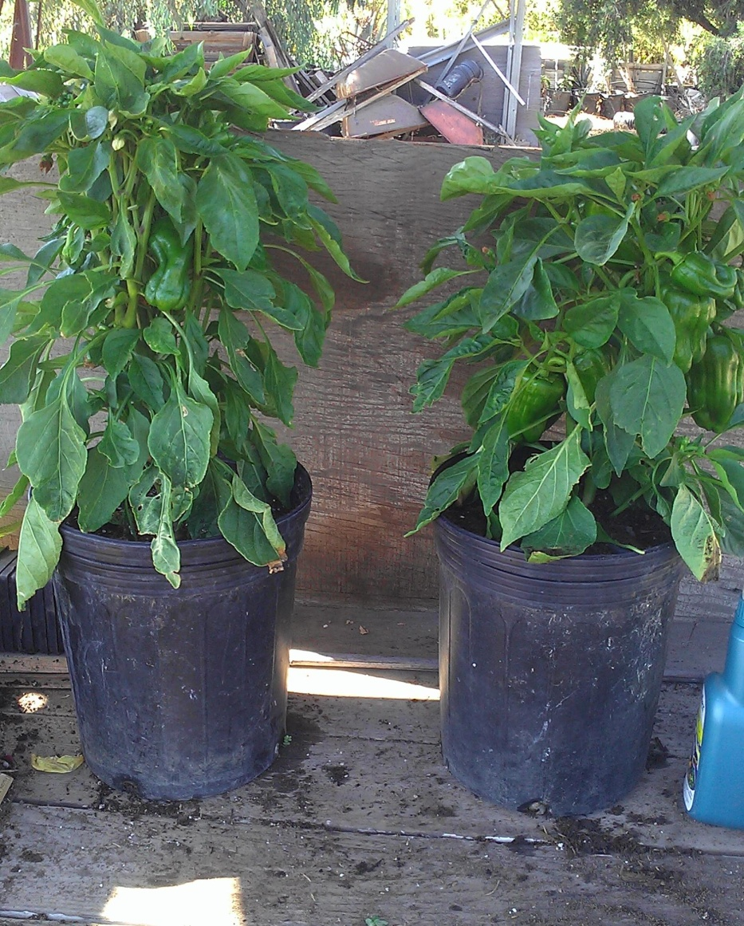
Untreated plant on left and treated plant on right.

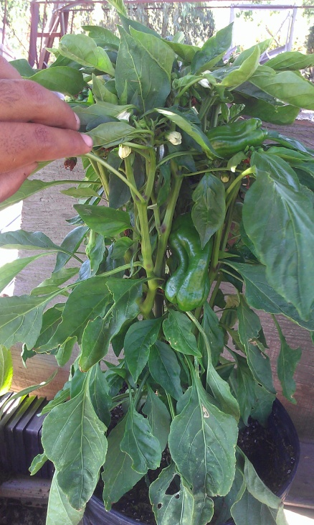
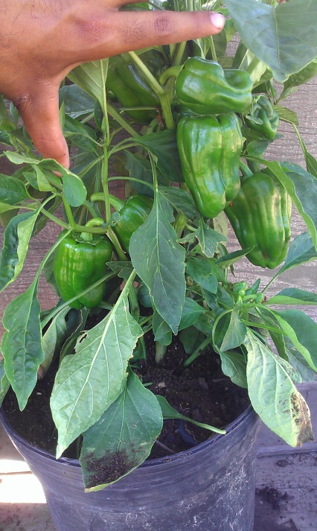

Untreated on left is still in flowering stage, treated on right has already yielded several peppers.
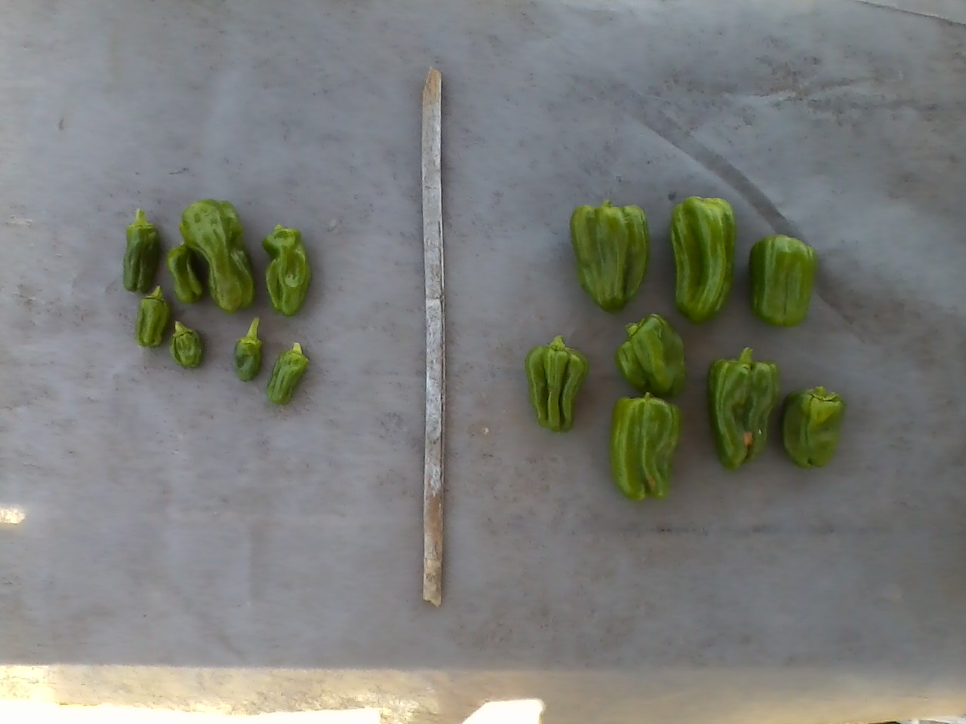
Untreated yield vs treated yield

Treated plant was significantly more drought resistant and produced larger peppers earlier than untreated. Also recovered much more rapidly from drought than the untreated plants.

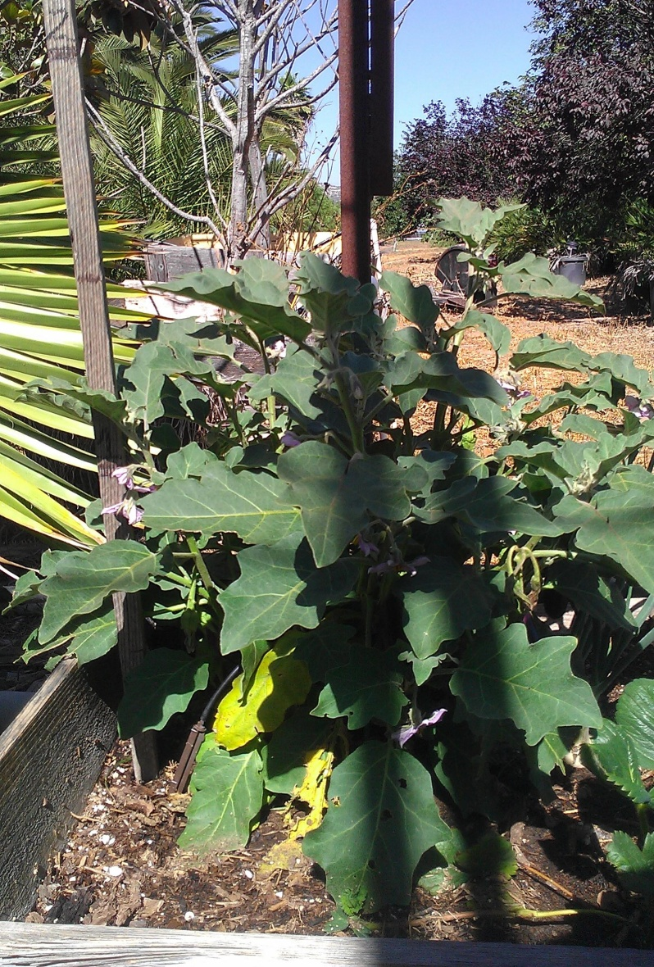
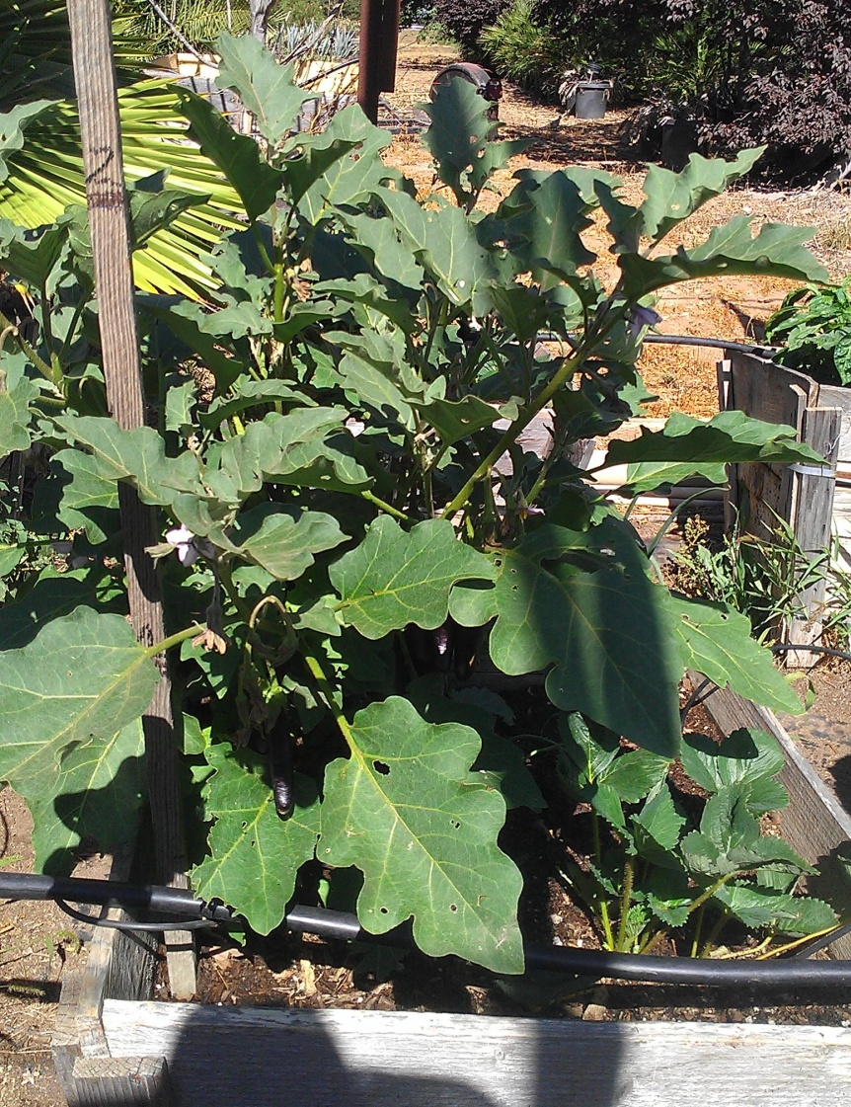
- Eggplant

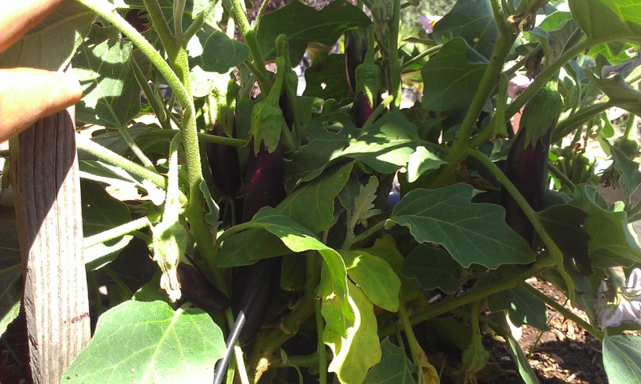
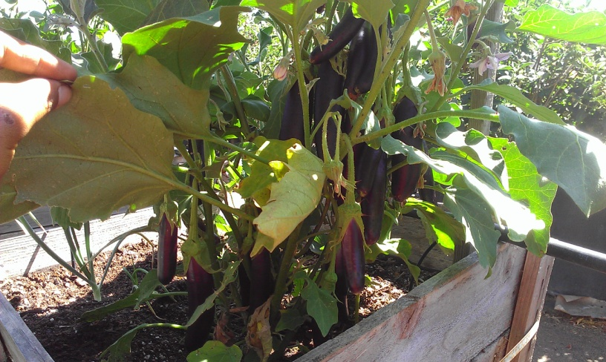
Untreated on left and treated on right

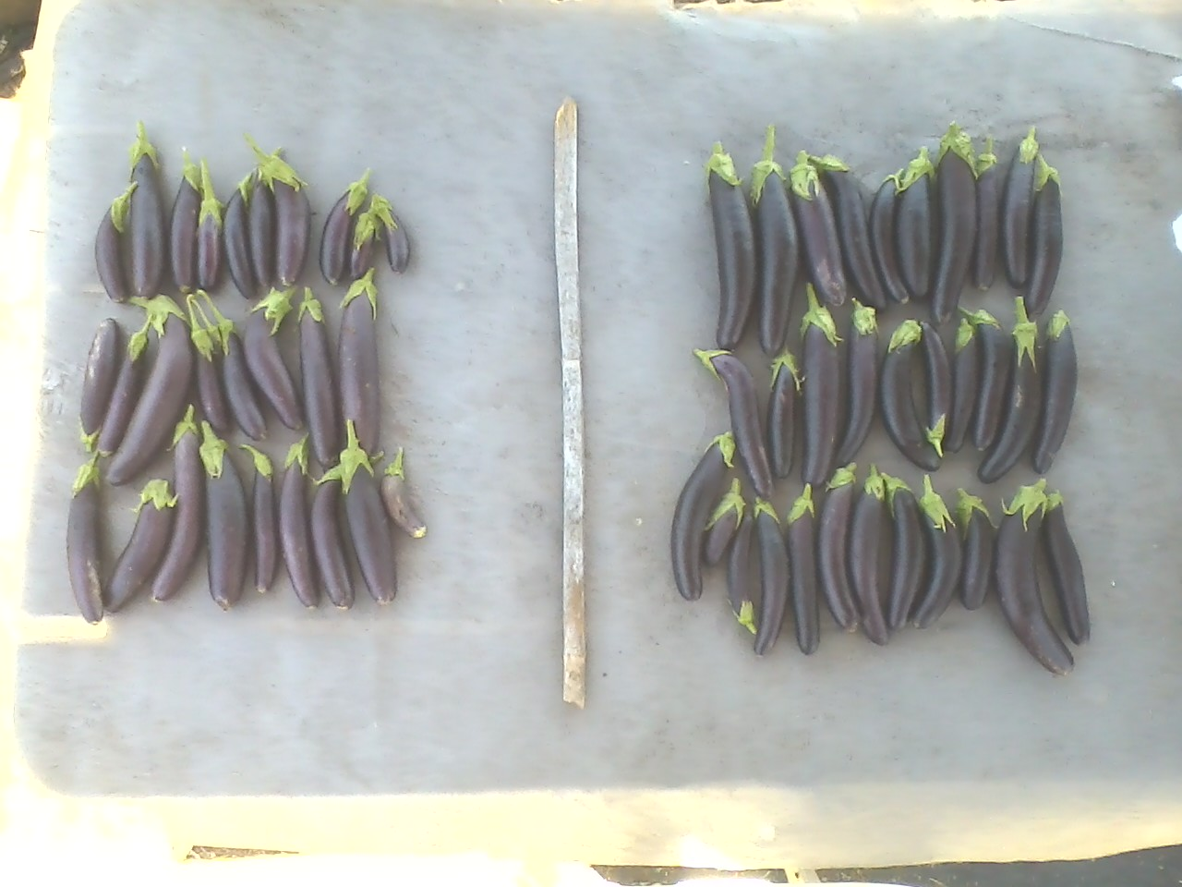
1st harvest untreated and treated eggplant

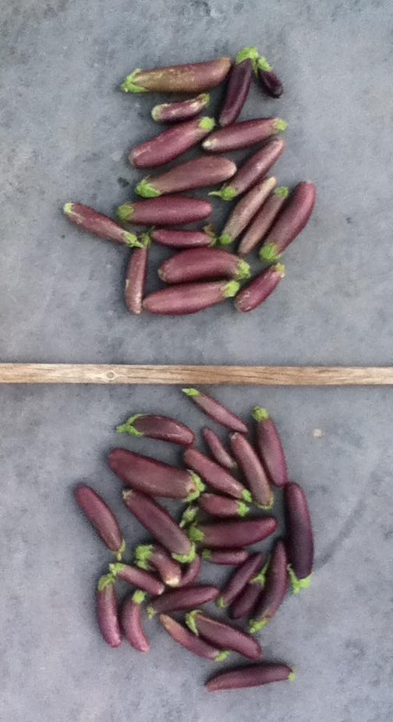
2nd harvest Untreated and treated

Treated eggplant was about 6” bigger than the untreated, and produced about 20 to 30% more yield. The treated plant was also more drought resistant and healthier. It was stronger and able to hold more produce.

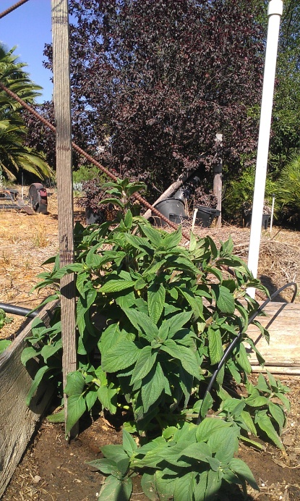
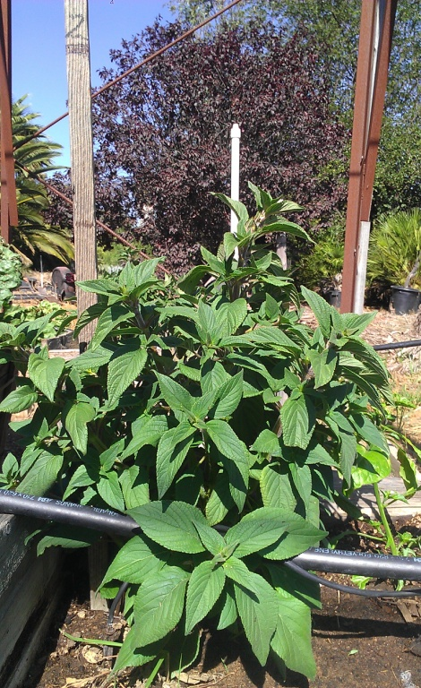
- Pineapple Sage

Untreated on left and treated on right.
Treated plant if bigger, has bigger leaves, and has stronger branches.
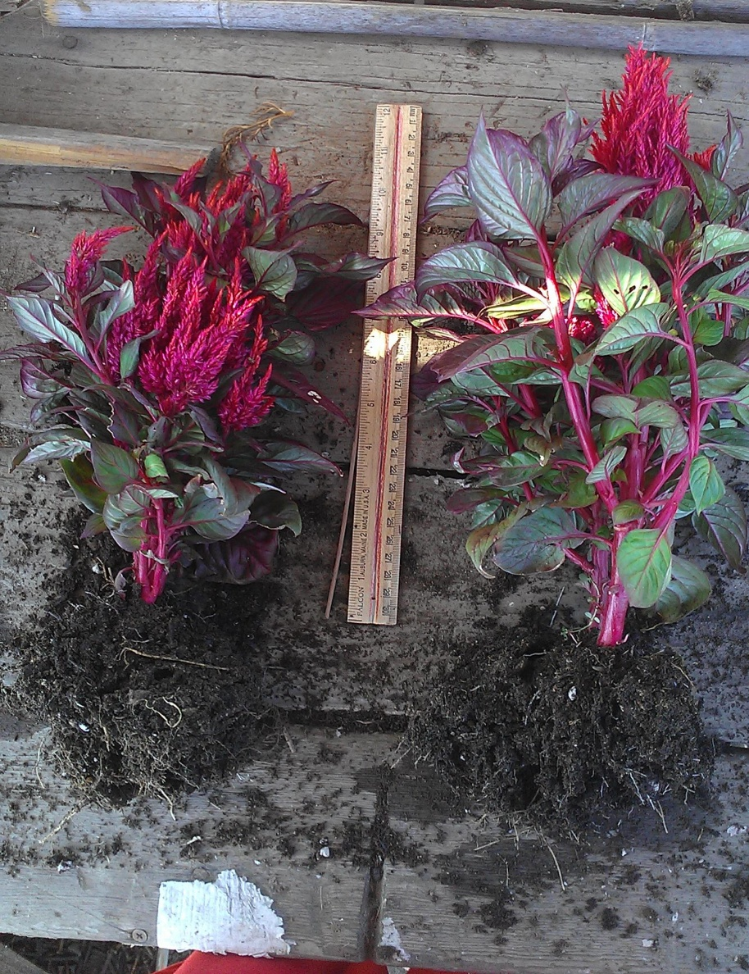
- Celosia
Untreated and treated plant
Treated has more color, leaves are more purple and more full. Plant has more vigor and a bigger root mass.

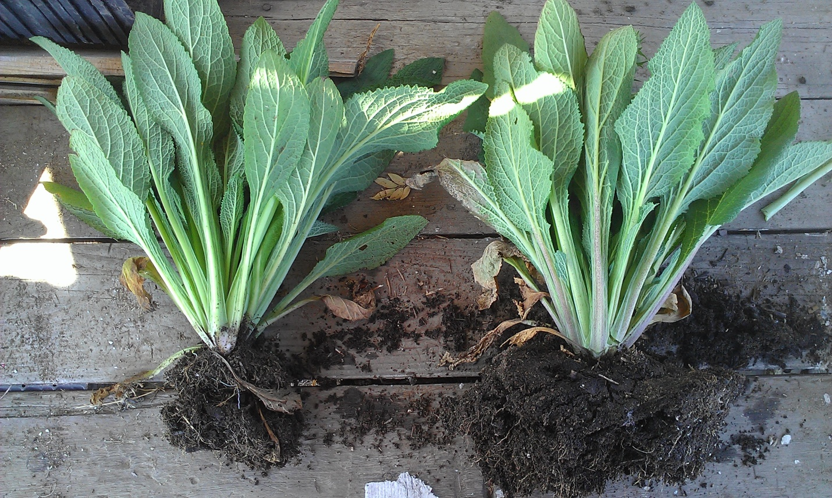
- Foxglove

Untreated and treated plants. Known to be poisonous. Treated plant has a stronger root system and larger root zone, therefore the plant is stronger.
Conclusion:
Soil conditions are optimized to allow better plant growth and protection against pests, diseases, and drought by using beneficial microorganisms. Therefore plants grow stronger, healthier, with more vigor and can produce a better quality crop. Bottom line, increased yield with reduced costs.
Microbe MAXX & Seed MAXX Field Test Results
Applied Seed MAXX as seed coating on cantaloupe, roma tomato, corn, tomatillo, and mustard green.
Applied Micobe MAXX as soil drench to bell peppers and jalapenos, Big Bertha peppers, eggplant, pineapple sage, celosia, and foxglove.
Plants were treated the same. Same watering schedule, no fertilizers or pesticides were added.

